MIT APP INVENTOR DESIGN AND CODE

App Layout
Buttons:
  - Start: Sends the "START" command to the ESP32 web server.
  - Stop: Sends the "STOP" command to the ESP32 web server.
  - Update Location: Fetches location from ThingSpeak.
  - Show Location: Displays the location on Google Maps using a WebViewer.
  - Refresh: Resets the app to its initial state.
Web Components:
  - Web1: Fetches GPS data from ThingSpeak.
  - Web2: Sends "START" and "STOP" commands to the ESP32.
Designer View
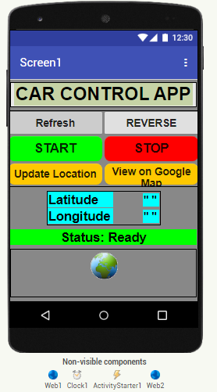
Fig 1: MIN Inventor Designer Window

App Blocks Explanation:

Start Button:
  - Sets Web2 URL to /start and triggers the ESP32 server to start the car.
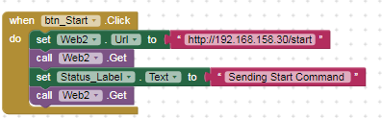
Fig 2: MIN Inventor Start Button Block
Stop Button:
  - Sets Web2 URL to /stop and triggers the ESP32 server to stop the car.
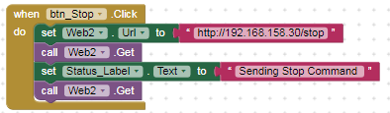
Fig 3: MIN Inventor Stop Button Block
Update Location Button:
  - Fetches latitude and longitude from ThingSpeak using Web1.
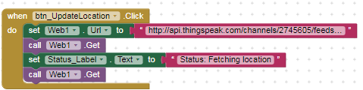
Fig 4: MIN Inventor Update location Button Block

View Location on Google map Button:
  - Loads Google Maps URL in WebViewer with the latest coordinates.
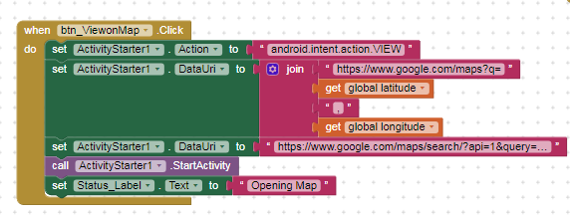
Fig 5: MIN Inventor Location on Google map Button Block
Web1 Code: Fetches GPS data from ThingSpeak.
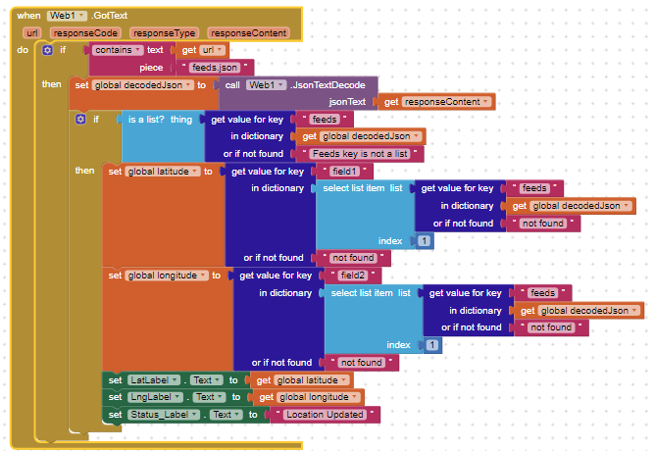
Fig 6: MIN Inventor Web1 Block

Web2 Code: Sends "START" and "STOP" commands to the ESP32
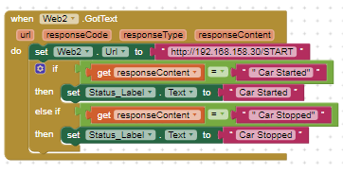
Fig 7: MIN Inventor Web2 Block

Reverse Button Commands

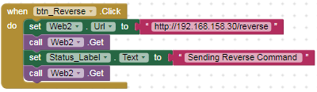
Fig 8: MIN Inventor Web2 Block

OUTPUT AND RESULT

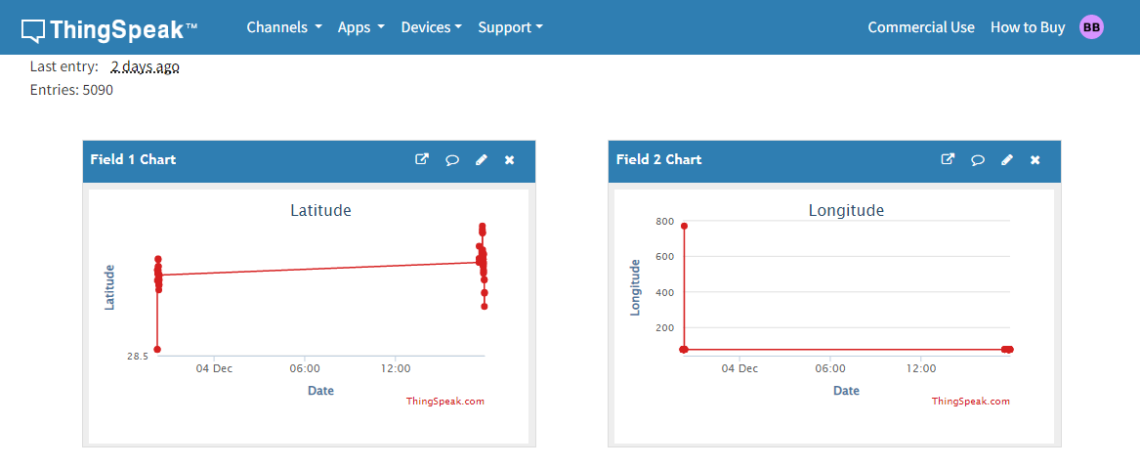

Fig 9- ThingSpeak Output

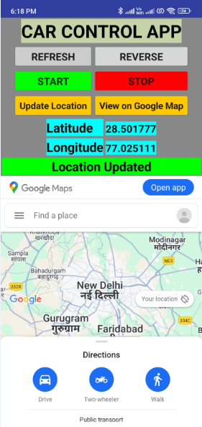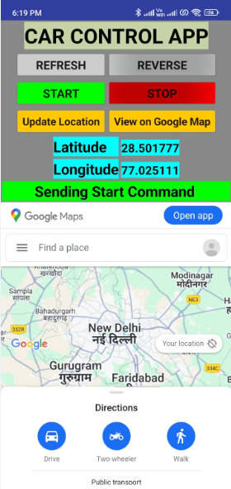

Fig 10- MIT APP showing updated location Fig 11- MIT APP sending Start command

